Deploy Radis via helm:

User the following to setup:

<https://hub.helm.sh/charts/bitnami/redis>

helm repo add nginx-stable <https://helm.nginx.com/stable>

Access to Prometheus:

<http://127.0.0.1:9090/>

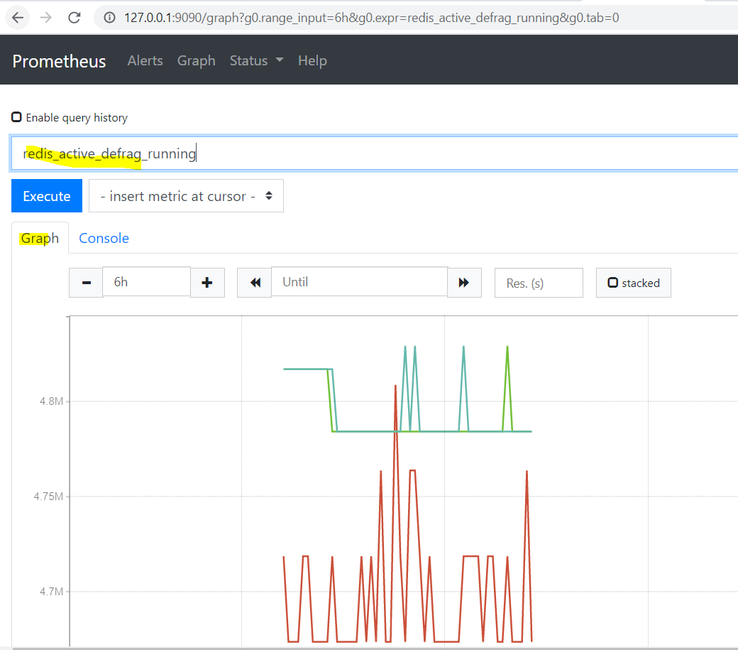

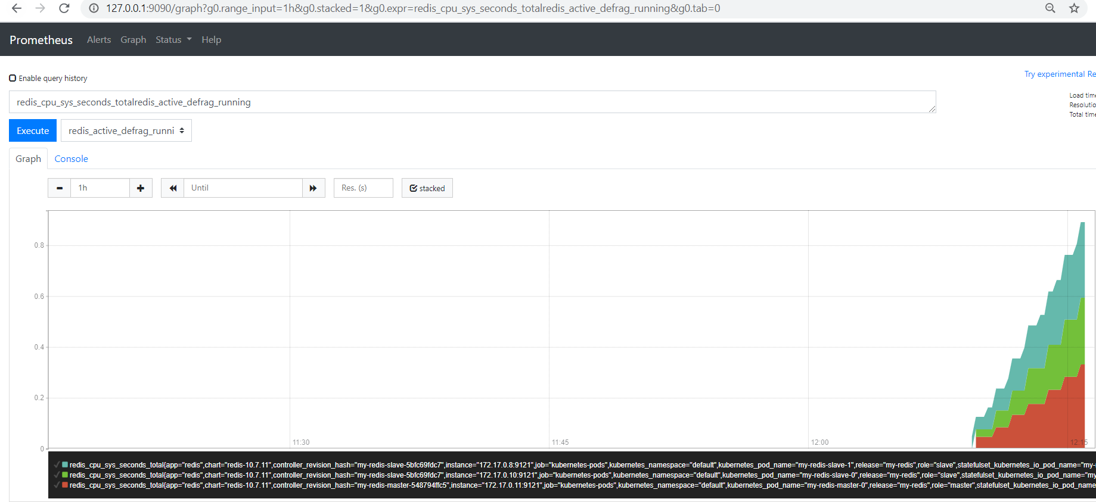

Connect to Gtafana:

<http://127.0.0.1:3000/?orgId=1>

Add data source. Go to configuration 🡪 data sources 🡪 add the following:

<http://prometheus-server.monitoring.svc.cluster.local>

Add a new dashboard suitable for Redis:

Find one here: <https://grafana.com/grafana/dashboards>

We will add dashboard number you find relevant.

Or via redis git (can load json file):

<https://github.com/oliver006/redis_exporter/tree/master/contrib>

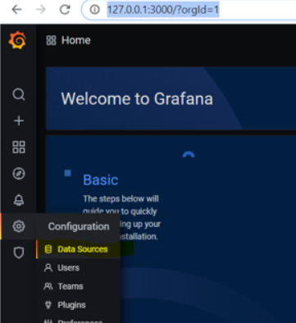

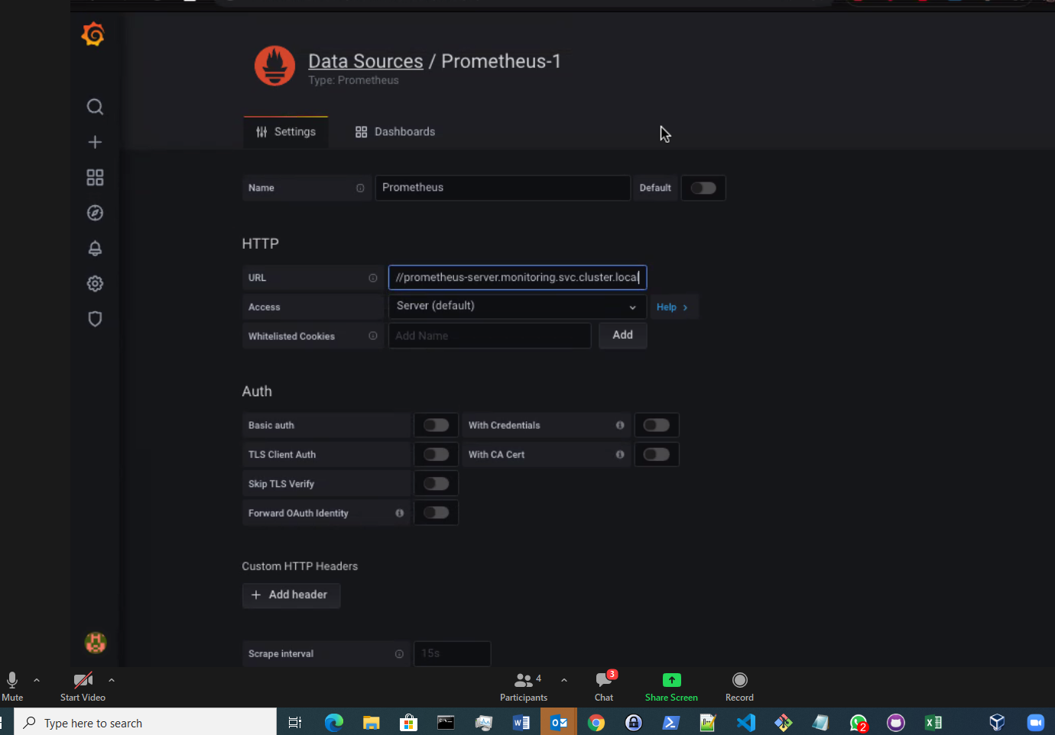

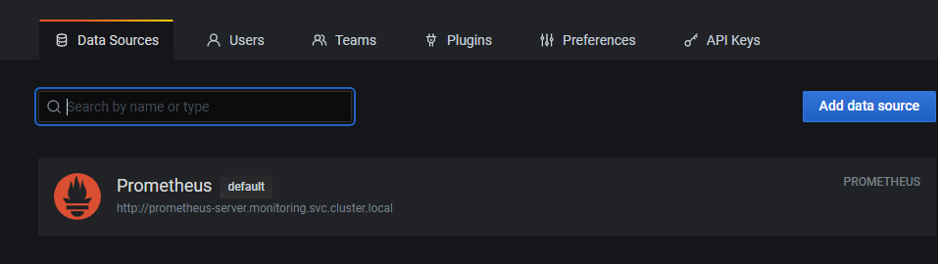

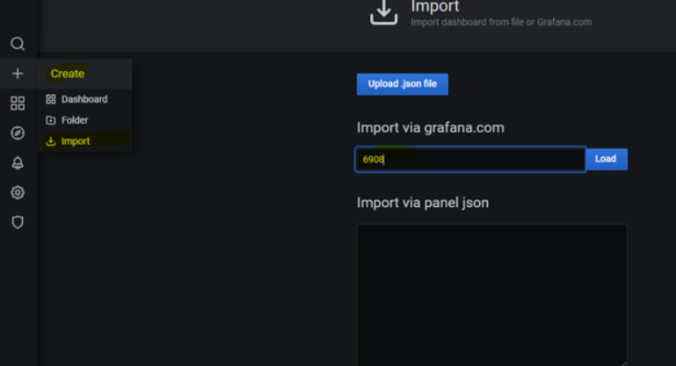

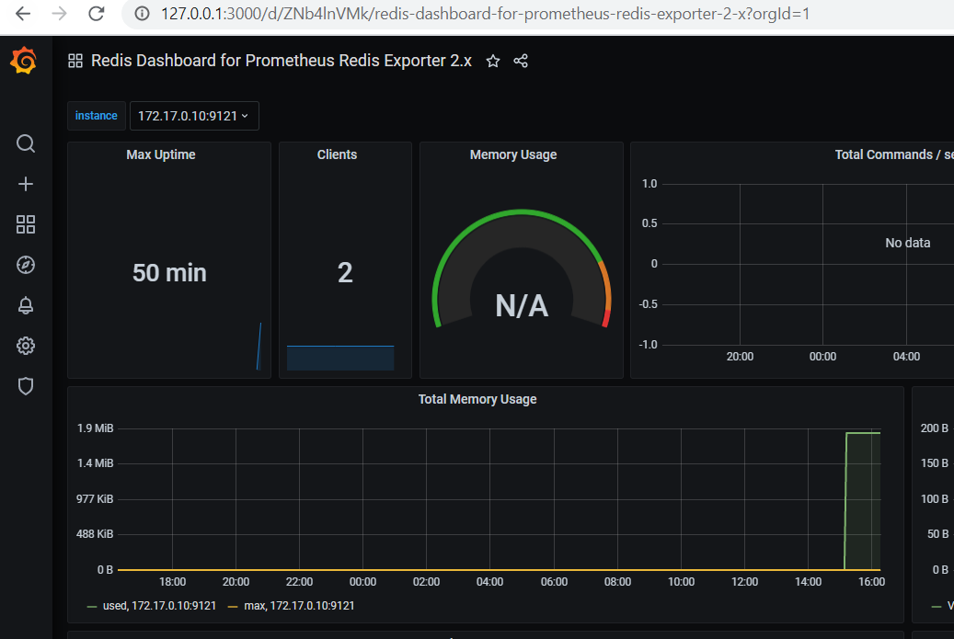

**BONUS1** :K8s dashboard:

<https://grafana.com/grafana/dashboards/6417>

and import it:

